This document is merely to point out the differences in confessional count numbers between my findings and the official numbers posted on Survivor Sucks. The guidelines I use can be found [here](https://docs.google.com/document/d/18ofsPiVWxSejzSjEGlU8KEx4Og2ddEJScCV23RsCPIA/edit?usp=sharing).

**Survivor Sucks Season 04 Counts** ([link](https://goo.gl/photos/6WSRJc2ACmyYZoLU7))

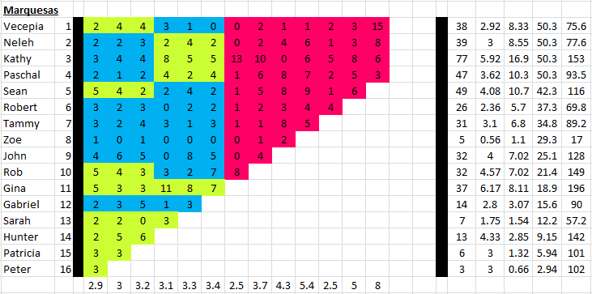

**My Season 04 Counts** (link)

**Differences**

[Episode 01](https://docs.google.com/document/d/1emLnwCj6ZOoI4u8PbtHvm4SyUa_hlAKu7AilyI2eDm0/edit?usp=sharing)

* **Sean 6 (+1)** Confessional #6 has a 10s gap.
* **John 5 (+1)** I counted a total of 5 confessionals for John instead of the established 4. No significant gaps.
* **Rob 7 (+2)** Confessional #34 has a 13s gap.
* **Gina 6 (+1)** Confessional #27 has a 12s gap.
* **Peter 5 (+2)** Confessional #24 has an 11s gap.

Episode 0

**No Change**

* Episode

|  |  |  |
| --- | --- | --- |
| **Castaway** | **Count** | **Change** |
|  |  |  |
| **Total** |  |  |

**Revised Sucks Counts** (link)